**Mechi Multiple Campus**

(Tribhuvan University)

Bhadrapur, Jhapa



**Lab Report of Probability & Statistics (CAST 202)**

Faculty of Humanities & Social Sciences

Tribhuvan University

Kritipur, Nepal

**Submitted By**

**Name:** Santosh Bhandari

**Roll No:** 58 (3rd Semester)

**Submitted To**

Mechi Multiple Campus

Department of Bachelor in Computer

Bhadrapur, Jhapa, Nepa

**CERTIFICATE FROM THE SUPERVISOR**

This is to certify that the Lab Report entitled **“Probability and Statistics”** is an academic work done by “Santosh Bhandari” submitted in the partial fulfillment of the requirements for the degree of Bachelor of Computer Application at Faculty of Humanities and Social Sciences, Tribhuvan University under my guidance & supervision. To the best of my knowledge, the worked performed by him in the Lab Report is his own creation.

Signature of the Supervisor:

Name: Kumar Subedi

Designation: Professor

Date:

**ACKNOWLEDGEMENT**

This report is specially designed to develop and enhance the knowledge of student in SPSS software. The assigned report is for the partial fulfillment of BCA (Bachelor in Computer Application) third semester student.

I would like to express my sincere gratitude to my subject teacher **“Mr. Kumar Subedi”** and the whole faculty of Humanities and Social Sciences who gave me this opportunity to fulfill this report. He gave me moral support and guided in different matters regarding the topics. He had been very kind and patient while suggesting me the outlines. I thank him for his overall support.

I am also thankful to everyone who all supported me, for that I have completed my report effectively and moreover on time. They gave me many helpful comments which helped me a lot in preparing it.

**TABLE OF CONTENTS**

CONTENT PAGE NO

1. Introduction to SPSS…..…………….…………………………. 1
2. Mean, Median and Mode for Individual Series ………………… 2-5
3. Mean, Median and Mode for Discrete Series ………………….. 6-10
4. Quartiles, Percentiles and Deciles for Individual Series ……….. 11
5. Quartiles, Percentiles and Deciles for Discrete Series ………….. 12
6. Range, S.D and CV for Individual Series ………………………. 13
7. Range, S.D and CV for Discrete Series …………………………. 14
8. Correlation ………………………………………………………. 15
9. Regression ………………………………………………………… 16-17
10. Graphs …………………………………………………………….. 18-19

**Introduction to SPSS**

The SPSS (Statistical Package for the Social Science) is the software for editing and analyzing all sorts of data. These data may come from basically any source: scientific research, a customer database etc. SPSS can open all file formats that are commonly used for structured data such as:

1. Spreadsheets from MS-Excel or Open Office
2. Plain text files (.txt or .csv)
3. Relational (SQL) Database
4. Stata and SAS

When you use SPSS, you work in one of several windows: the data view, the variable view, the output view, the draft output view, and the script view. Eventually, you will also use the syntax editor to save or refine your queries.

**Data View:** The data view displays your actual data and any new variables you have created.

**Variable View:** At the bottom of the data window, you will notice a tab labeled variable view. The variable view window contains the definitions of each variable in your data set including its name, type, label, size, alignment, and other information.

**Output Window View:** The output window is where you see the results of your various queries such as frequency distributions, cross-tabs, statistical tests, and charts. If you have worked with Excel, you are probable used to seeing all your work on one page, charts, data, and calculations. In SPSS, each window handles a separate task. The output window is where you see your results.

**Calculating Mean, Median and Mode of Individual Series**

**Data: 12, 9, 13, 10, 9, 11, 14, 15, 17, 20, 12**

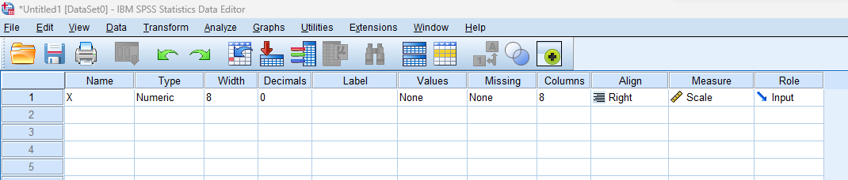Declaring the Variable as a X:

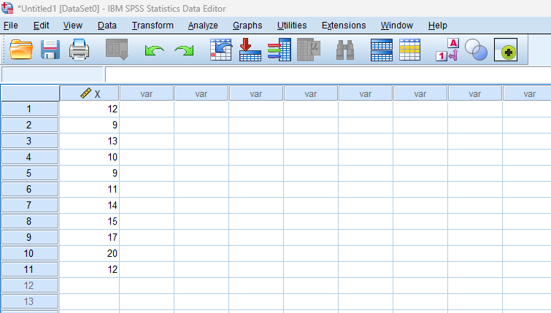Inserting the Given Data:

Choosing the Variable and Selecting the Option we Want to Calculate:

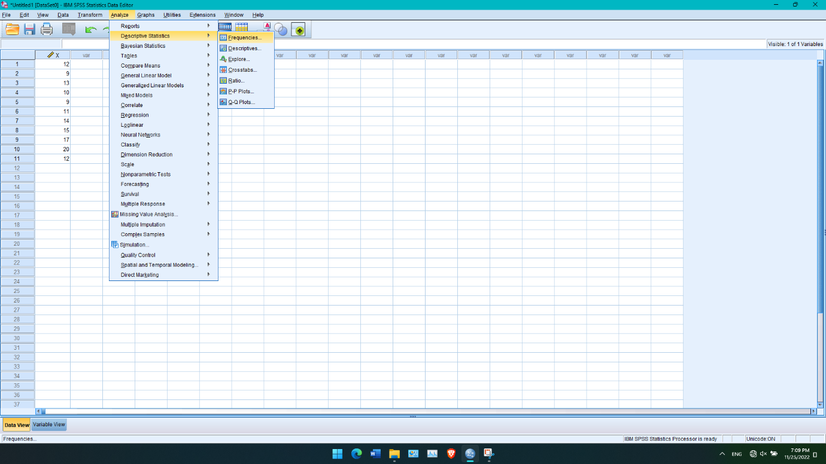

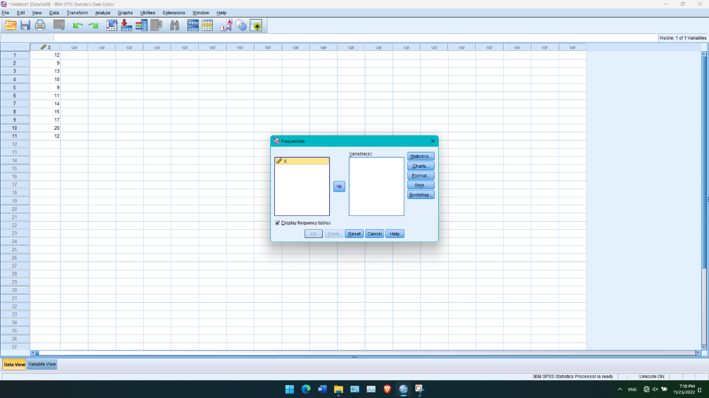

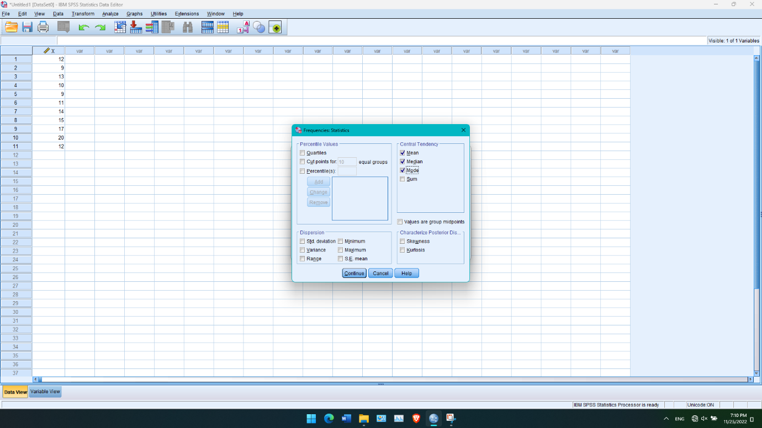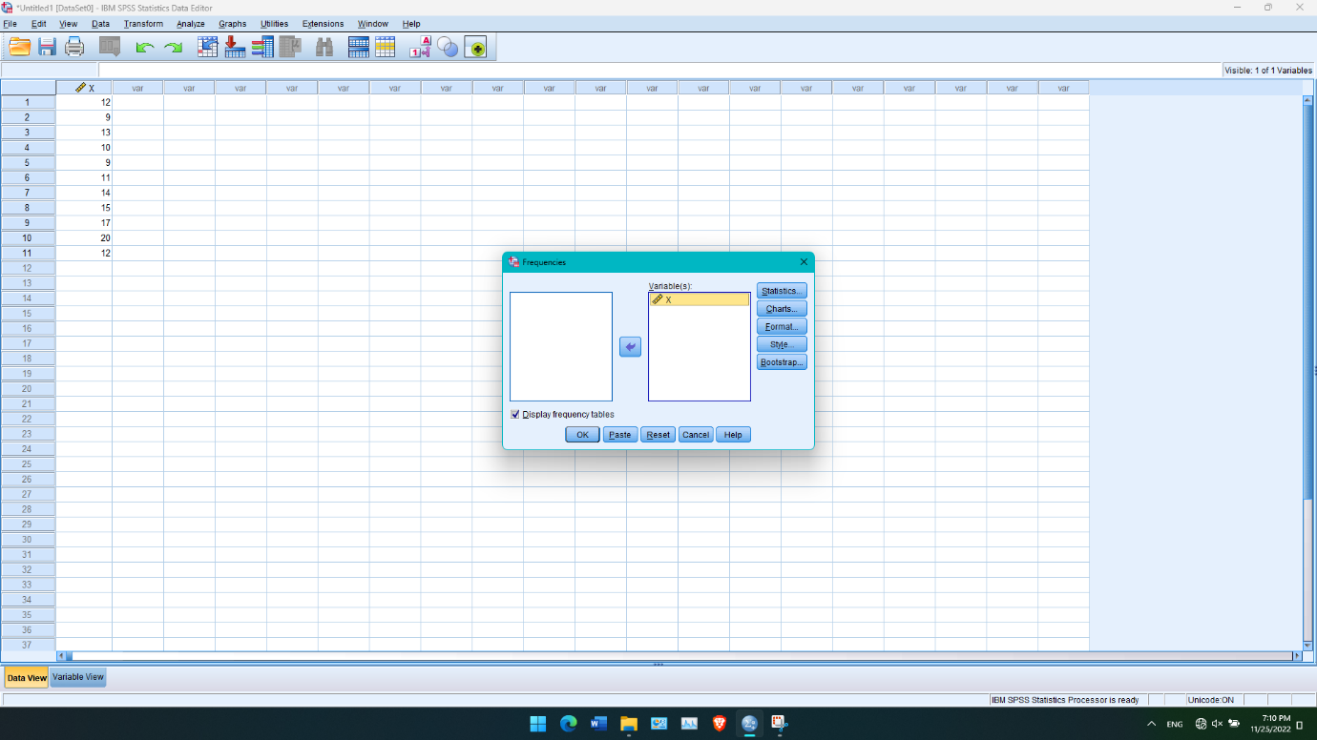

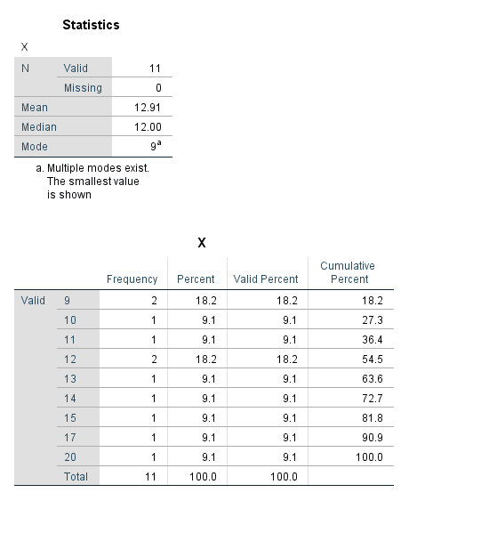Output of the Given Data:

**Calculating Mean, Median and Mode of Discrete Series**

Data:

|  |  |  |  |  |  |  |  |  |  |
| --- | --- | --- | --- | --- | --- | --- | --- | --- | --- |
| Marks Obtained(X) | 10 | 20 | 30 | 40 | 50 | 60 | 70 | 80 | 90 |
| No. of Students(f) | 3 | 6 | 9 | 20 | 25 | 18 | 7 | 3 | 1 |

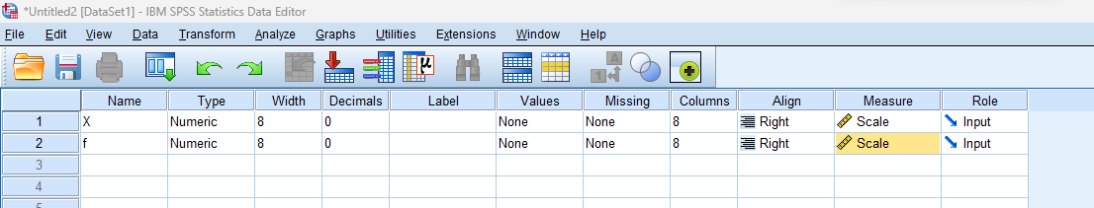Declaring the Variable as X and f.

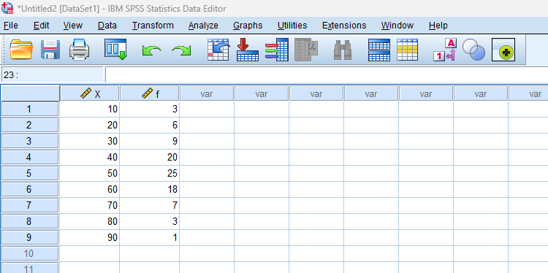Inserting the Given Data:

Choosing the Variable and Frequency and also Selecting the Option we Want to Calculate:

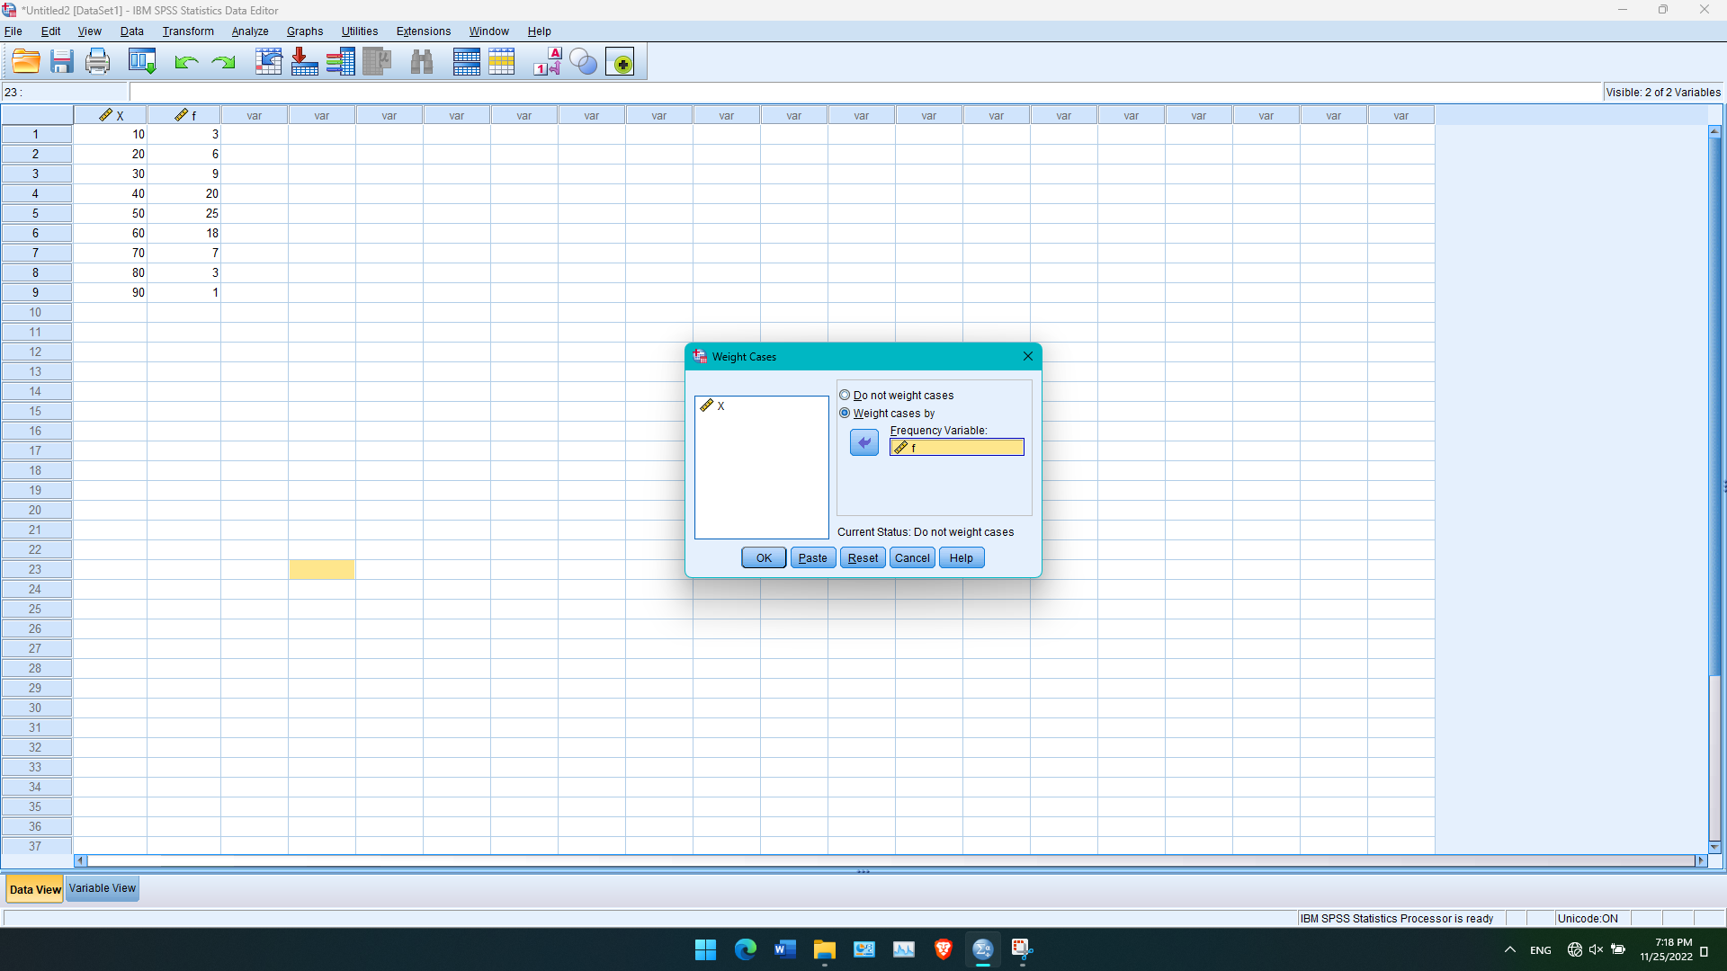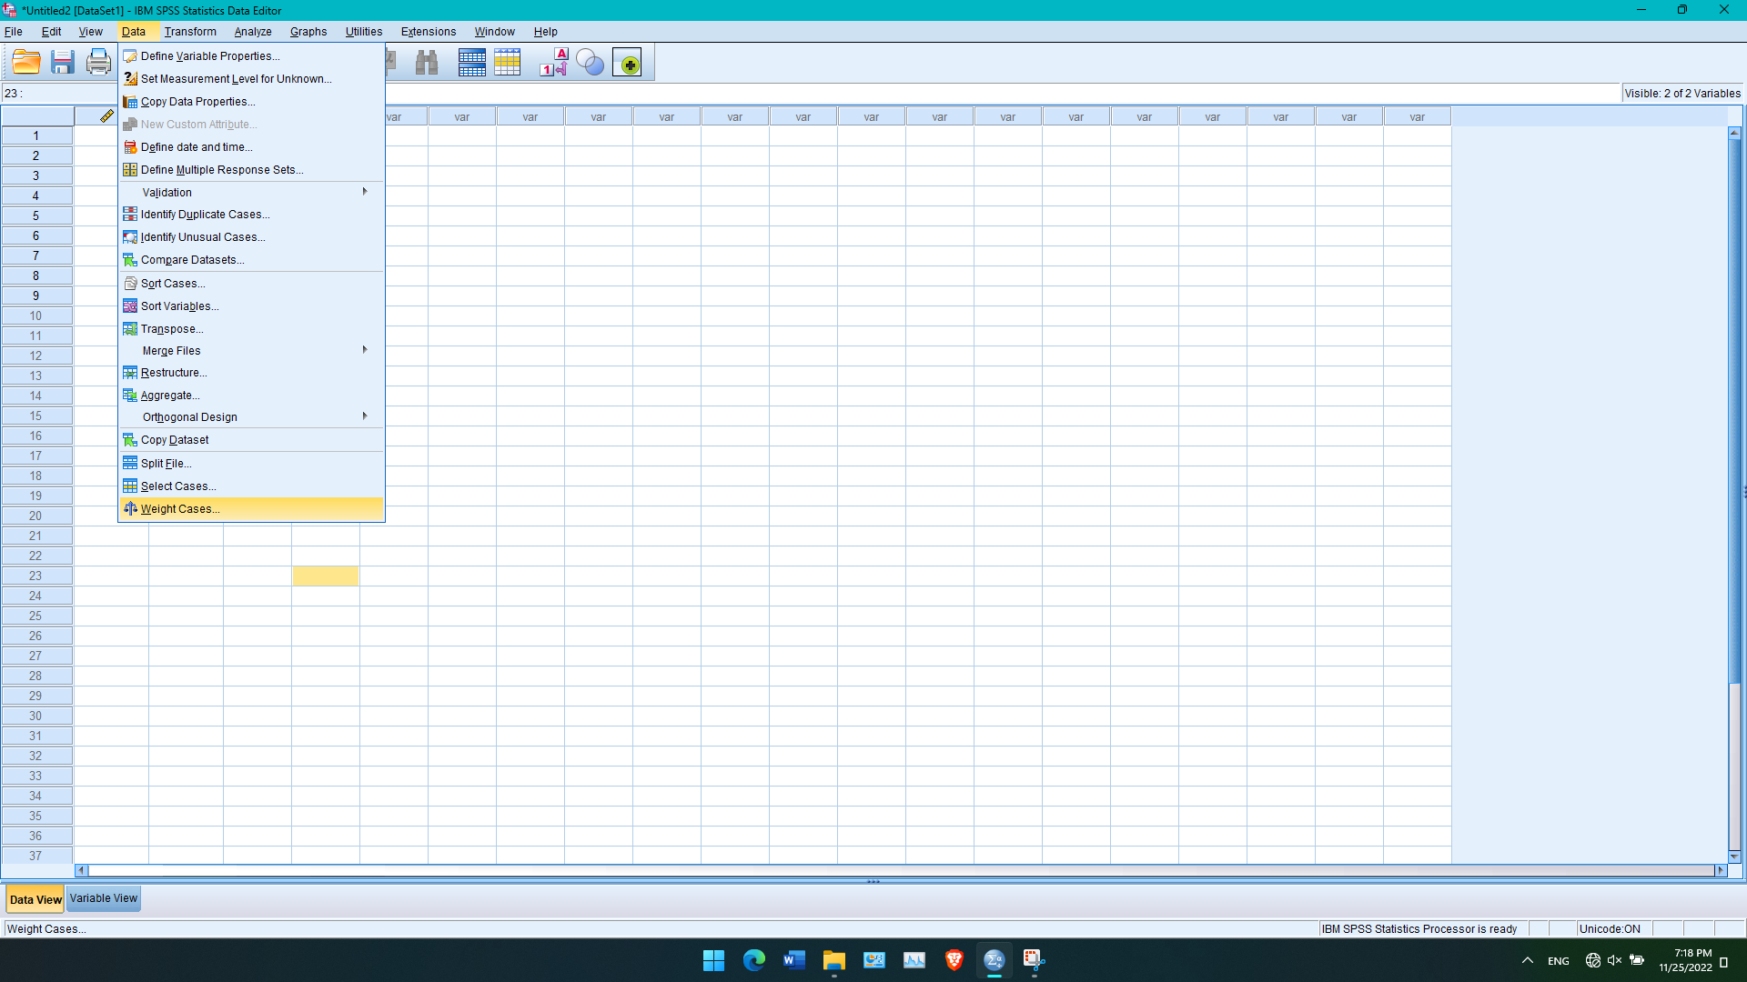

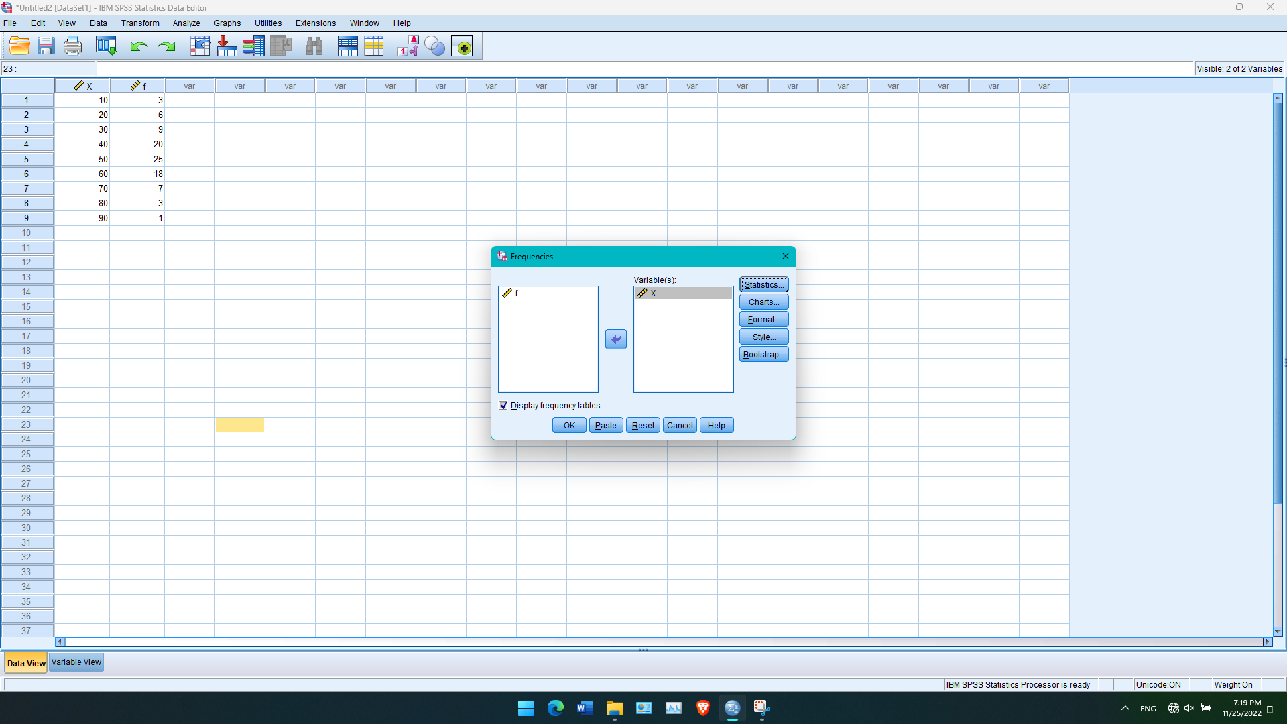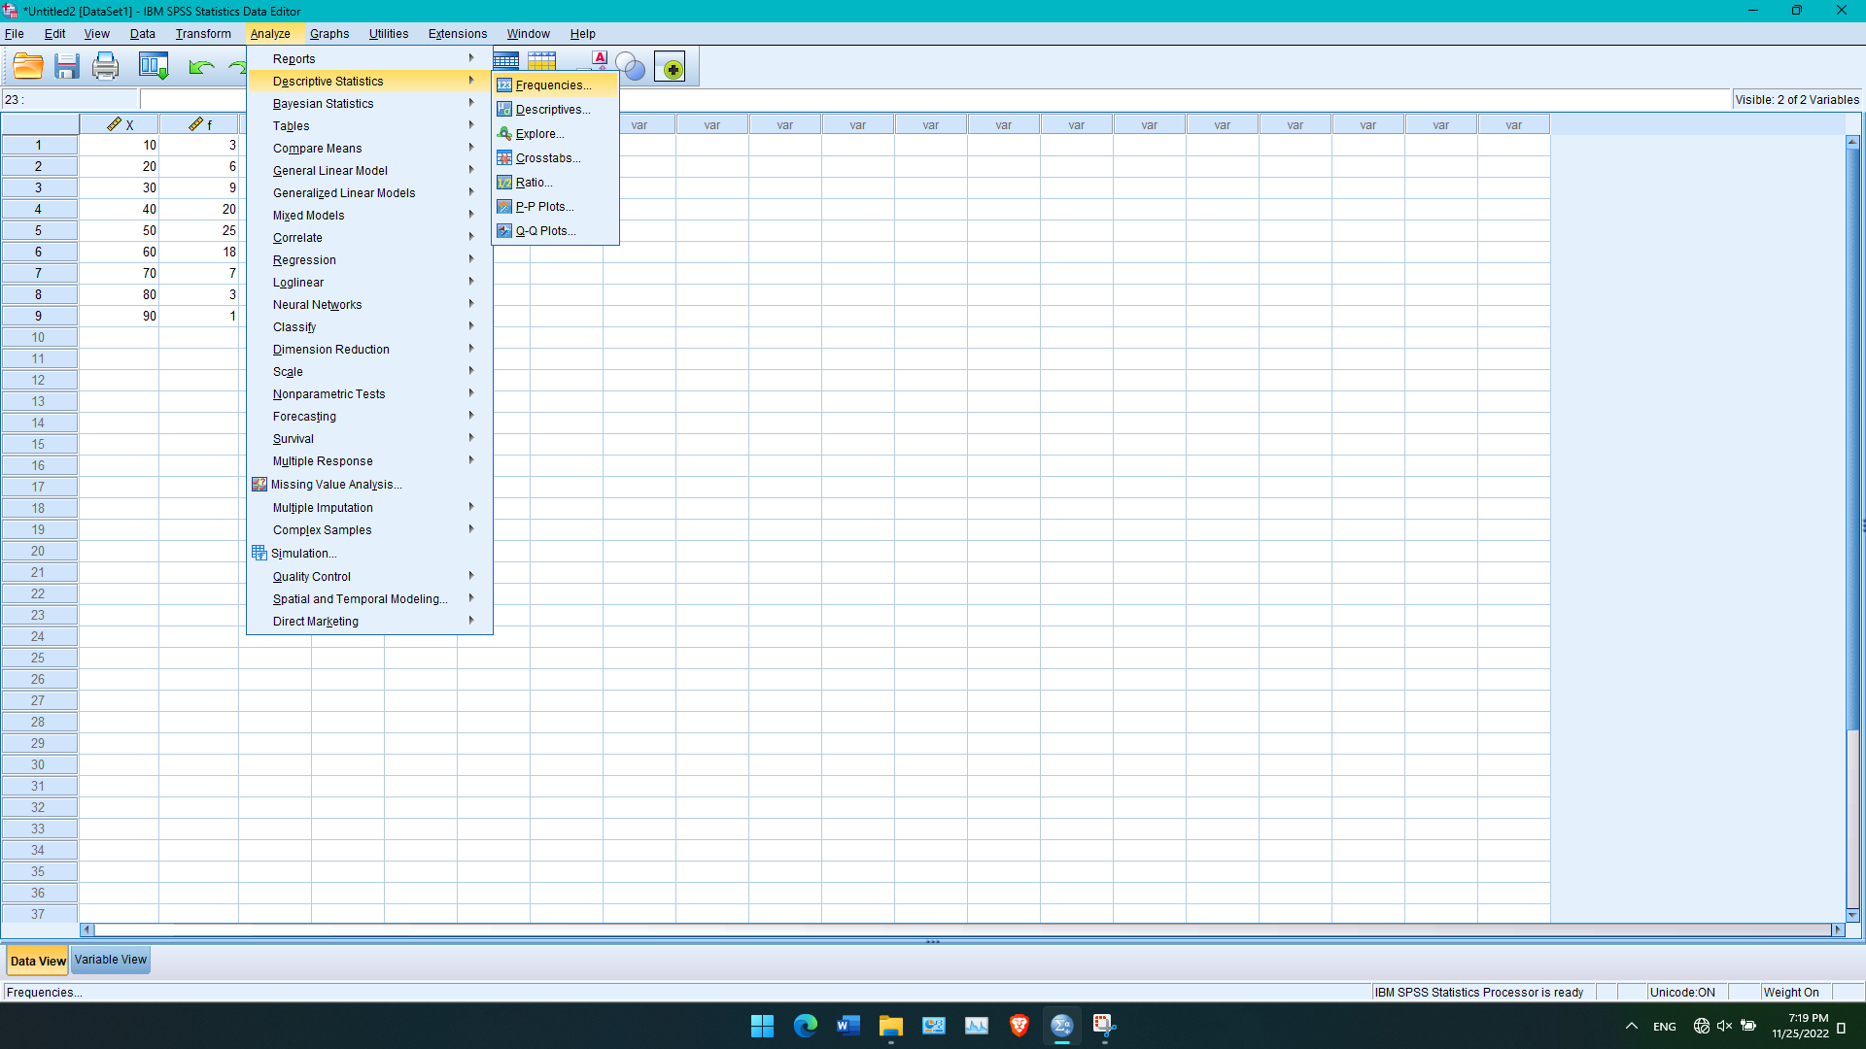

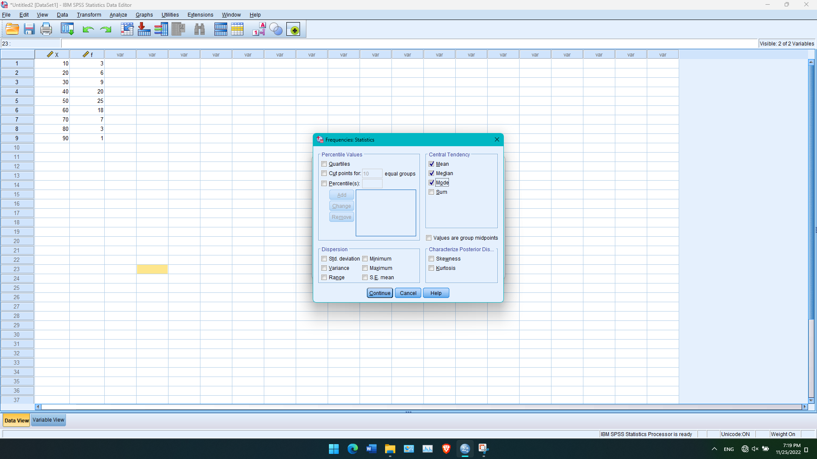

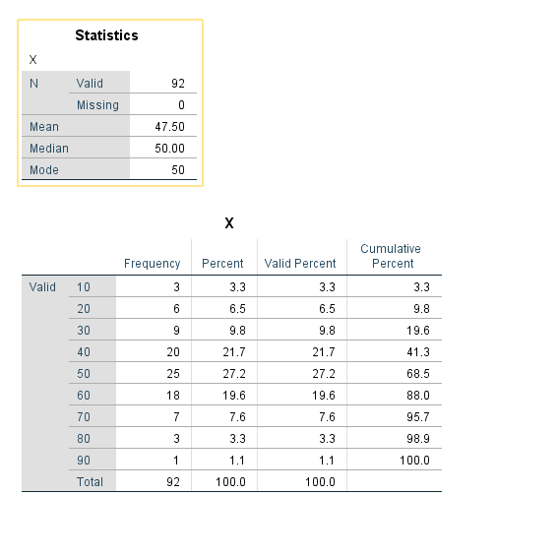Output of the Given Data:**Calculating Quartiles, Deciles and Percentiles of Individual Series**

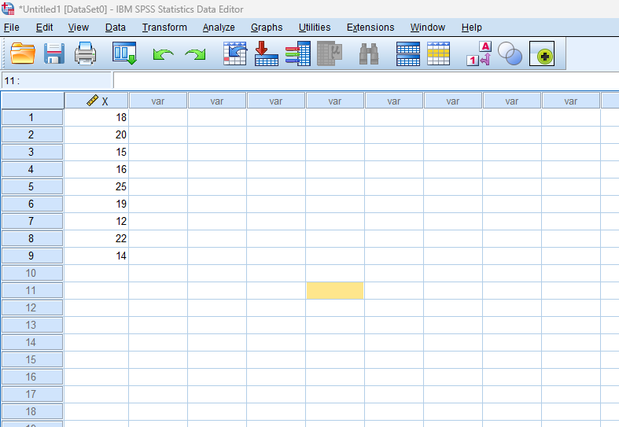Data: 18, 20, 15, 16, 25, 19, 12, 22, 14

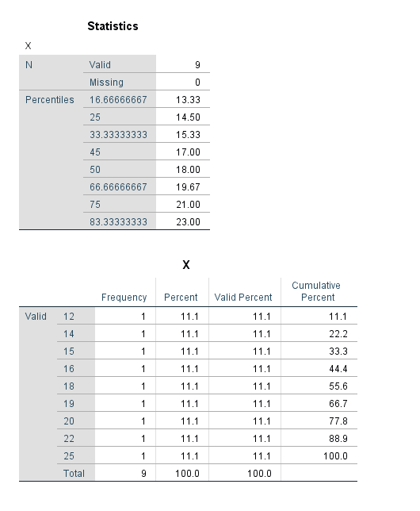Output of the Given Data:

**Calculating Quartiles, Deciles and Percentiles of Discrete Series**

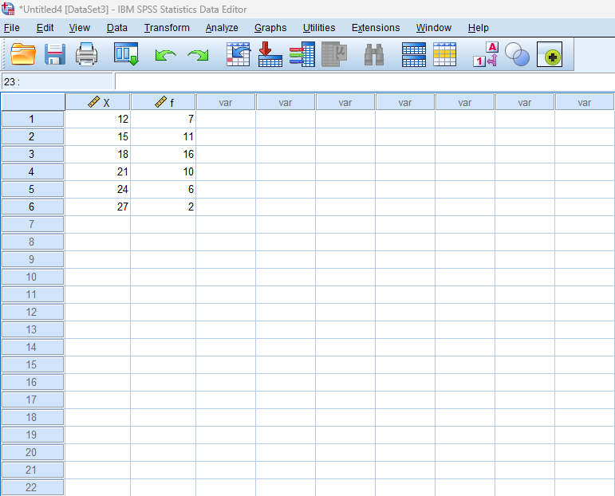Data:

|  |  |  |  |  |  |  |
| --- | --- | --- | --- | --- | --- | --- |
| Marks Obtained(X) | 12 | 15 | 18 | 21 | 24 | 27 |
| No. of Students(f) | 7 | 11 | 16 | 10 | 6 | 2 |

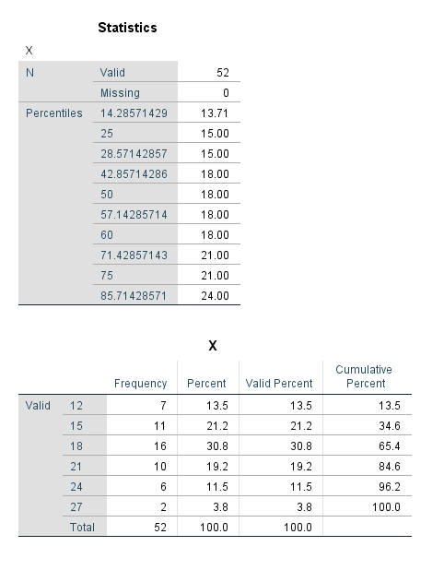Output of the Given Data:

**Calculating Range, S.D and C.V of Individual Series**

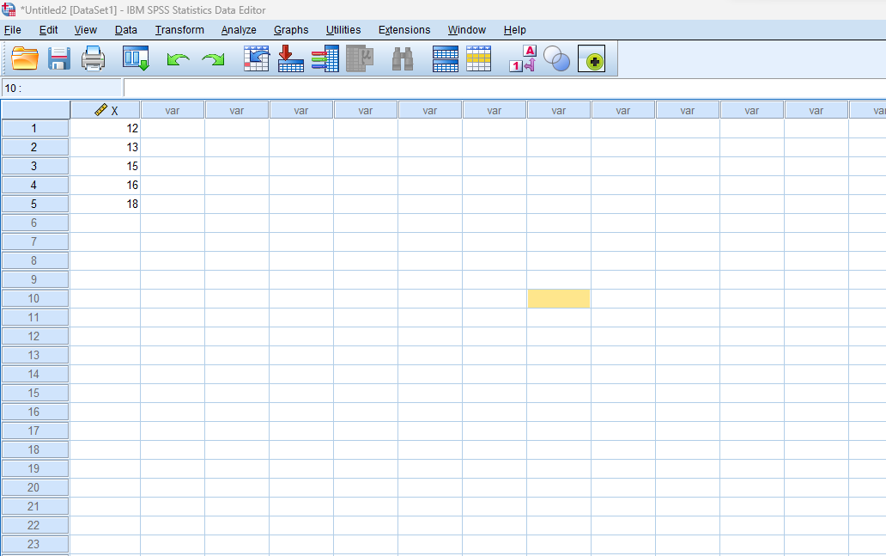Data: 12, 13, 15, 16, 18

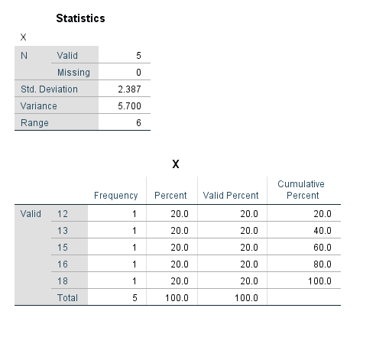Output of Given Data:

**Calculating Range, S.D and C.V of Discrete Series**

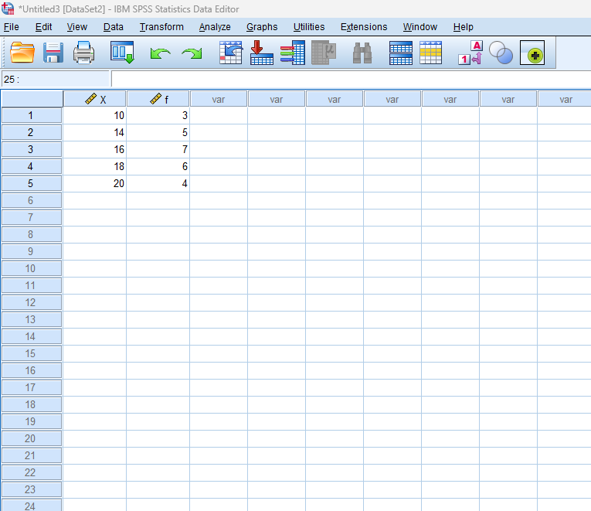Data:

|  |  |  |  |  |  |  |
| --- | --- | --- | --- | --- | --- | --- |
| Marks Obtained(X) | 12 | 15 | 18 | 21 | 24 | 27 |
| No. of Students(f) | 7 | 11 | 16 | 10 | 6 | 2 |

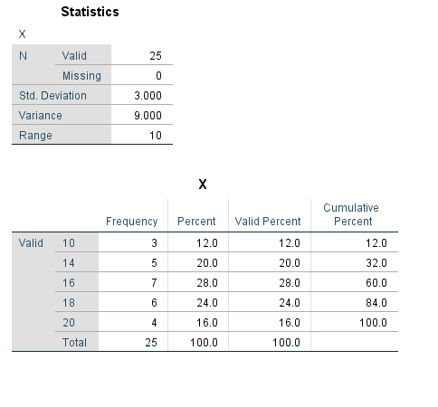Output of Given Data:

**Calculating Correlation between Two Variable X and Y**

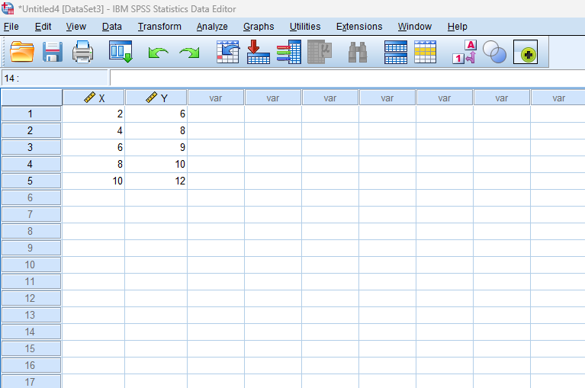Data:

|  |  |  |  |  |  |  |
| --- | --- | --- | --- | --- | --- | --- |
| X | 12 | 15 | 18 | 21 | 24 | 27 |
| Y | 7 | 11 | 16 | 10 | 6 | 2 |

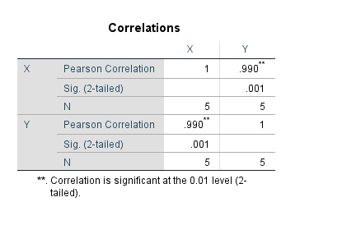Output of the Given Data:

**Calculating Regression Where X is depends upon Y**

Data:

|  |  |  |  |  |  |  |
| --- | --- | --- | --- | --- | --- | --- |
| Marks Obtained(X) | 12 | 15 | 18 | 21 | 24 | 27 |
| No. of Students(f) | 7 | 11 | 16 | 10 | 6 | 2 |

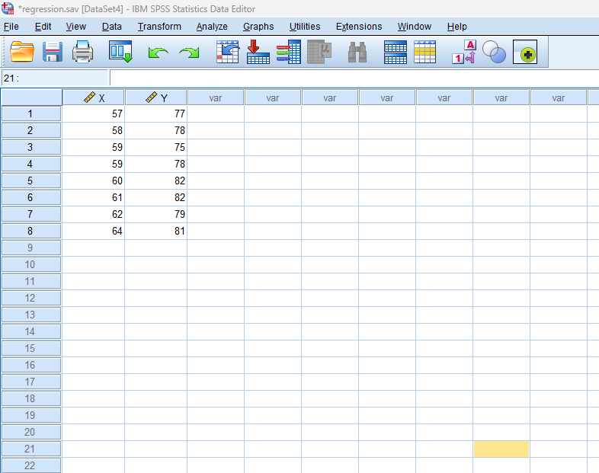

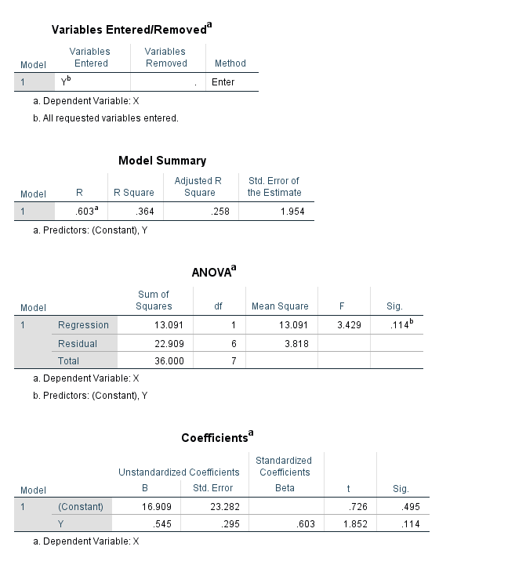Output of Given Data:**Generating Different Types of Graphs**

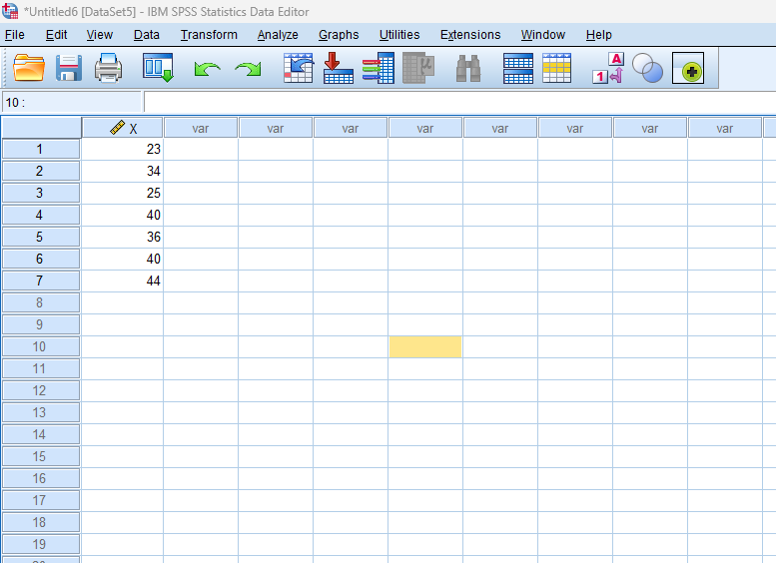Data: 23, 34, 25, 40, 36, 40, 44

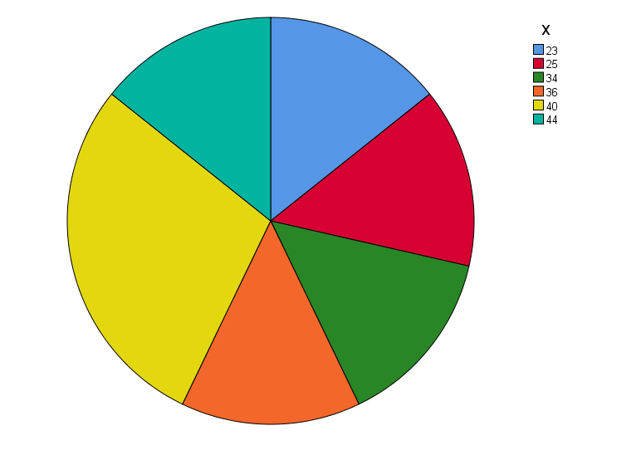Presenting in Pie Chart:

Presenting in Bar Chart:

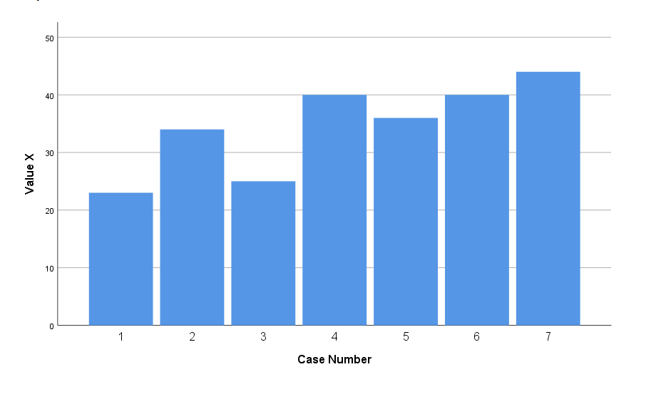

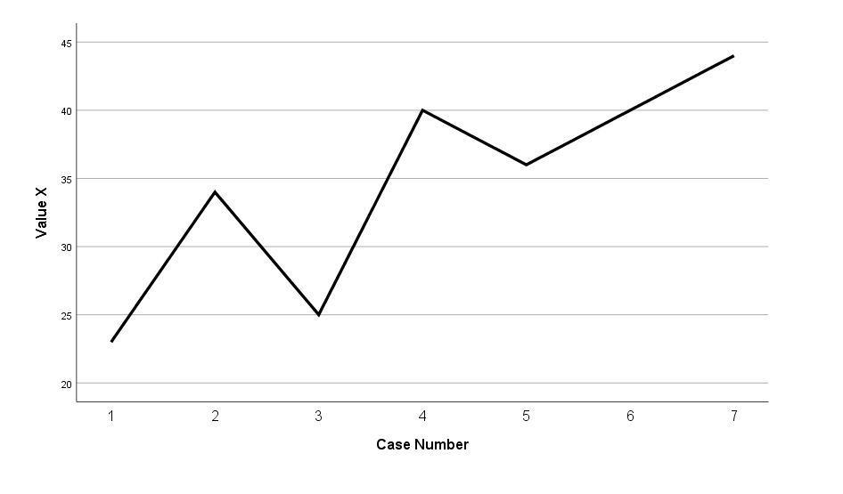Presenting in Line Chart: